**Basic Cartography**

**Figure 1**

Figure 1 indicates county population, roads and earthquake magnitude in the state of California plotted as per the steps given in the lab.

**Figure 2**

Figure 2 has been implemented after implementing steps given in **option 4,** it tells us that San Francisco, Ridgecrest and Los Angeles are the most earthquake prone cities in the state of California.

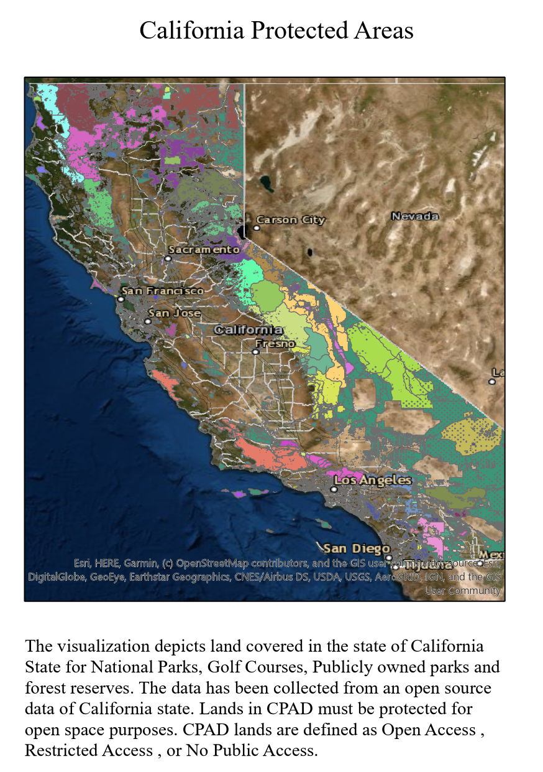

**Figure 3**

For the above visualization, I chose **option 1.** The dataset that I incorporated was CPAD (California Protected Areas). It indicates acres of land by access type. Graduated colors indicate various types of access like open, restricted, no public. The California Protected database areas inventories open space lands that have been protected for open spaces uses through fee ownerships. An earthquake activity can prove very fatal to such humungous acres of land being used for various purposes affecting mankind.

**Discussion Questions**

1. What area of California are most susceptible to earthquake hazards in terms of earthquake frequency, magnitude and population density?

Ans: Southern California Coast has most earthquakes with San Andreas fault being primary feature. Los Angeles and San Francisco are major cities that are sitting duck for giant earthquake.

2. Limited access highways can move the largest number of people. What area of California would be most susceptible to earthquakes causing damage to Limited access highways?

Ans: Limited access highways in Ridgecrest, San Francisco, Los Angeles, San Diego, San Jose are susceptible to earthquakes causing damage.

3. What spatial patterns do you see emerging in your map? What might those patterns imply for disaster management issues?

Ans: San Francisco, Ridgecrest and Los Angeles are the most earthquake prone areas in the state of California. In 2019, an earthquake of 7.1 magnitude had struck Southern California and in less than 2 days Ridgecrest experienced an earthquake of 6.4 magnitude near northeast of Los Angeles. An event of earthquake disrupts everything, all these visualizations can help disaster management team to be extra careful when it comes to zones that are more prone to earthquakes. This can help in causing less damage to people, animals, highways and forests.